**VALUER REPORT UID NO.:****CEV/RVO/299/4195/24022025 24.02.2025**

**FORMAT OF VALUATION REPORT**

**To**

**The Chief Manager ,**

**CANARA Bank, SME,**

**Branch: Sector 11, Panchkula**

**VALUATION REPORT (IN RESPECT OF LAND / SITE AND BUILDING)**

|  |  |  |  |  |  |  |  |  |  |  |  |  |  |
| --- | --- | --- | --- | --- | --- | --- | --- | --- | --- | --- | --- | --- | --- |
| **I** | General | | | | | | |  |  | | | | |
| 1. | Purpose of valuation | | | | | | | : | **Bank’s Purpose –Property already mortgaged with Canara Bank** | | | | |
| 2. | A | | | | | Date of Inspection | | : | 24.02.2025 | | | | |
| B | | | | | Date on which the Valuation is made | | : | 24.02.2025 | | | | |
| 3 | Name of the reported owner with present address and phone number  Name of the owner(s) and his/their addresses(es) with Phone No. (details of share of each owner in case of joint ownership) | | | | | | | : | Kusum Bansal w/o Vinod Kumar Bansal R/O HOUSE NO. 286, SECTOR 12A, PANCHKULA, HARYANA,  **100% share** | | | | |
| 3a | Name of Borrower/ Client | | | | | | | : | **Kusum Bansal w/o Vinod Kumar Bansal** | | | | |
| 4. | List of documents produced for perusal | | | | | | | : | - | | | | |
| 1.O | | | | | | |  | old valuation report dt. 07.02.2022 of Sh Raj Kumar Jangra valuer | | | | |
|  | 2. Sale deed | | | | | | |  | Deed No. 4087 dated 28.03.2013 | | | | |
| 5 | Brief description of the property (including leasehold/freehold etc) | | | | | | | : | **H.No. 286, Sector -12A, Urban Estate, Panchkula , Distt. Panchkula , Hr. Constructed on GF in a land area of 250sqyd**  **Freehold** | | | | |
|  | | | | | | |  |  | | | | |
| 6. | Scope of Valuation | | | | | | |  | **To compute present value of land and building** | | | | |
| 7 | If this report is to be used for any bank purpose, state the name of bank and branch, if known | | | | | | | : | **CANARA Bank, Branch: Sector 11, SME, Panchkula** | | | | |
| **II. DESCRIPTION OF THE PROPERTY** | | | | | | | | | | | | | |
| 1. | **Postal address of property with PIN code** | | | | | | |  |  | | | | |
| 2. | City/Town | | | | | | | : | City | | | | |
| Residential Area | | | | | | | : | Residential Area | | | | |
| Commercial Area | | | | | | | : | NA | | | | |
| Industrial Area | | | | | | | : | NA | | | | |
| 3 | Classification of the Area | | | | | | |  |  | | | | |
|  | i) | | | | | High/Middle/Poor | | : | Middle | | | | |
|  | ii) | | | | | Urban/Semi Urban/Rural | | : | Urban | | | | |
| 4 | Coming under Corporation limit/Village Panchayat/ Municipality | | | | | | | : | MC Panchkula / HSVP | | | | |
| 5 | Whether covered under any State/ Central Govt. enactments (e.g., Urban Land Ceiling Act) or notified under agency area / Scheduled area / cantonment area. | | | | | | | : | Legal opinion in this regard may be taken from legal counsel on the panel of bank | | | | |
| 6 | In case it is an agricultural land, any conversion to house site plots is contemplated . | | | | | | | : | NA | | | | |
| 7 | Location of Property | | | | | | |  |  | | | | |
| a) | | | | Plot No./Nagar/Survey No. | | | : | H.No. 287 | | | | |
| b) | | | | Door No. | | | : | H.No. 287 | | | | |
| c) | | | | S.F. No./ T.S. No./ R.S. No. | | | : | Sector -12A, Panchkula | | | | |
| d) | | | | Village/Block | | | : | Panchkula | | | | |
| e) | | | | Ward/Taluka | | | : | Panchkula | | | | |
| f) | | | | Mandal/District/ Municipality/ Corporation | | |  | Panchkula | | | | |
| 8 | Boundaries of the property | | | | | | | : | **As per Deed/ Docs** | | | **As per visit/ Actuals** | |
| North | | | | | | | : | - | | | H. No. 287 | |
| South | | | | | | | : | - | | | H. No. 285 | |
| East | | | | | | | : | - | | | Other property | |
| West | | | | | | | : | - | | | Front Road | |
| 9 | Latitude, Longitude and Coordinates of the site | | | | | | |  | **Lats. 300 40’ 28” N & Long. 76050’51”E** | | | | |
| 10 | Property tax receipt referred | | | | | | | : | NA | | | | |
| a) | | | | | Assessment number | |
| b) | | | | | Tax amount | |
| c) | | | | | Receipt in the name of | |
| 11 | Electricity service connection consumer number  In the name of, other details , if any | | | | | | | : | With owner | | | | |
| 12 | Property is presently occupied by . | | | | | | | : | Owner | | | | |
| 13. | If tenanted fully,  What is the gross monthly rent ? | | | | | | | : | NA, the house is not in use at present | | | | |
| 14. | If occupied by both  By assuming the entire building is let out, | | | | | | |  | Owner Occupied  NA  NA | | | | |
| a) | | | | | What is the probable monthly rent ? | |
| b) | | | | | What is the advance amount ? | |
| **III. PROCEDURE OF VALUATION :** | | | | | | | | | | | | | |
|  | Valuation Details | | | | | | | : | Discussed in Part B,C,D,E&F | | | | |
| 1 | F.S.I. | | | | | | |  | Not found in docs | | | | |
| 2 | Plot Coverage | | | | | | |  | Not found in docs | | | | |
| **(Describe the property details)**  **Part B- Land** | | | | | | | | | | | | | |
| 1 | Dimension of the site | | | | | | |  | A (As per Deed/ Docs) | | B (Actuals) | | |
|  | North | | | | | | |  | NA | | NA | | |
| South | | | | | | |  |
| East | | | | | | |  |
| West | | | | | | |  |
| 2 | Extent of the site(least of 1a & 1b) | | | | | | |  |  | | | | |
| Size of Plot | | | | | | |  | 209 sqm | | | | |
| North & South | | | | | | |  | - | | | | |
| East & West | | | | | | |  | - | | | | |
| Total Extent of the plot | | | | | | |  | 209 sqm as per deed and same is considered for valuation | | | | |
| **3** | **Characteristics of the site** | | | | | | |  |  | | | | |
| a | What is the character of the locality ? | | | | | | |  | Residential | | | | |
| b | What is the classification of the locality ? | | | | | | |  | Residential | | | | |
| c | Development of surrounding areas | | | | | | |  | Developed | | | | |
| d | Possibility of frequent flooding/sub-merging | | | | | | | : | Only in case of natural calamities | | | | |
| e | Feasibility to the Civic amenities like school, hospitals, bus stop, market etc. | | | | | | |  | The basic facilities are available at a distance of about 0.50 km to 3.0 km | | | | |
| f | Level of land with topographical conditions | | | | | | |  | Leveled | | | | |
| g | Shape of land | | | | | | |  | Rectangular | | | | |
| h | Type of use to which it can be put | | | | | | |  | Residential | | | | |
| i | Any usage restriction | | | | | | |  | Only Residential | | | | |
| j | Is plot in town planning approved layout? | | | | | | |  | Yes | | | | |
| k | Corner or intermittent House/flat/plot? | | | | | | |  | intermittent house | | | | |
| l | Type of road available at present | | | | | | |  | BT Road | | | | |
| m | Road facilities are available ? | | | | | | |  | Yes | | | | |
| n | Is it a land-locked land? | | | | | | |  | No, There is free access to property | | | | |
| o | Water Potentiality | | | | | | |  | Yes | | | | |
| p | Width of road-is it below 20 ft. or more than 20 ft. | | | | | | |  | More than 20 ft. | | | | |
| q | Underground sewerage system | | | | | | |  | Yes | | | | |
| r | Is power supply available at the site? | | | | | | |  | Yes | | | | |
| s. | Advantage of the site | | | | | | |  |  | | | | |
| 1. | | | | | | |  | Property located in Well developed Sector 12A in Panchkula | | | | |
|  | 2. | | | | | | |  | NA | | | | |
| t. | Special remarks, if any, like threat of acquisition of land for public service purposes, road widening or applicability of CRZ provisions etc. (Distance from sea-coast/tidal level must be incorporated) | | | | | | |  | Legal opinion in this regard may be taken from counsel of the bank | | | | |
| a | | | Any factors which affect the marketability of the land ? | | | |  | NA | | | | |
| b | | | Type of the land ? | | | |  | Residential | | | | |
|  | c | | | Accessibility | | | |  | There is free access to property | | | | |
| 4 | Value on adopting GLR | | | | | | |  | - | | | | |
| a | | | Guidelines Rate obtained from the Registrar’s office (an evidence thereof to be enclosed) | | | |  | 52800/- per sqm | | | | |
| b | | | Value of land by adopting GLR | | | |  | Rs. 52800 *209 sqm = **Rs. 110.35 Lac** | | | | |
| 5 | Value by adopting PMR (Prevailing Market Rate) | | | | | | |  |  | | | | |
| a | | Prevailing market rate (Along with details/reference of at least two least deals/transactions with respect to adjacent properties in the areas) | | | | |  | Rs.210000 to 220000 per sqm | | | | |
| b | | Unit rate adopted in this valuation after considering the characteristics of the subject plot value of land by adopting PMR | | | | |  | Rs.2,14,000/- per sqm | | | | |
| **Part-C - Buildings** | | | | | | | |  |  | | | | |
|  | Type of Building (Residential/ Commercial/ Industrial) | | | | | | |  | Residential | | | | |
| 1. | Type of Construction (Load bearing / RCC /Steel Framed) | | | | | | |  | Load bearing | | | | |
| 2 | Quality of construction (superior /I class/ II class) | | | | | | |  | 1st Class | | | | |
| 3 | Appearance of building ( Common/attractive/ aesthetic) | | | | | | |  | Common | | | | |
| 4 | Maintenance/ Condition of the building | | | | | | |  |  | | | | |
|  | i) | | | Exterior-Excellent, Good, Normal, Poor | | | |  | Normal | | | | |
| ii) | | | Inferior-Excellent, Good, Normal, Poor | | | |  | Normal | | | | |
| 5 | Plinth area floor-wise | | | | | | |  | **Covered Area on GF= 1007 sft as per old valuation report dt.** **07.02.2022** **of Sh Raj Kumar Jangra valuer as sanctioned building plan not provided by the client** | | | | |
| 6. | Number of floors and height of each floor including basement, if any | | | | | | |  | GF floors with 10’ height | | | | |
| **Floor** | | **Year of Construction (as reported/ as per actual observation /as per deed)** | | | | | **Roof ht. in ft.** | | **Plinth area** | | | | |
| **Main Portion A** | **Cantilevered portion B** | | | **Total A + 50 % of B** |
| **GF** | | 2000 | | | | | 10’ | | 1007.00 sft. | nil | | | **1007.00 sft.** |
| **Drawing Approval** | | | | | | | | | | | | | |
| A | Date of issue and validity of layout of approved map/ plan | | | | | | |  | **Sanctioned by HUDA by not made available by the client to valuer** | | | | |
| B | Approved map / plan issuing authority | | | | | | |  | HUDA, Panchkula | | | | |
| C | Whether genuineness or authenticity of approved map / plan is verified- | | | | | | |  | As per HUDA, Panchkula | | | | |
| D | Any other comments by our empanelled Valuers on authenticity of approved plan | | | | | | |  | no | | | | |
| e | (Discuss on the building approval, reference , violations observed, consequences of violation etc.) | | | | | | |  | **Covered area taken as per old valuation report dt. 07.02.2022** | | | | |

**8. Value of Building is estimated by adopting suitable unit plinth area rate depending upon the specifications. Depreciation is calculated by straight line method assuming a salvage value of 10 % .**

|  |  |  |  |  |  |  |  |  |  |  |  |  |
| --- | --- | --- | --- | --- | --- | --- | --- | --- | --- | --- | --- | --- |
| **Valuation of Building** | | | | | | | | | |  | | |
| **Sr. No** | **Description** | | | | | | **Ground floor** | | | **FF ---- NOT ERECTED** | | |
| 1. | Specification | | | | | | RCC Roof slab over load bearing walls | | | - | | |
| 2. | Floor finish | | | | | | Italian Marble | | | - | | |
| 3. | Superstructure | | | | | | Brick Masonry in cement sand mortar | | | - | | |
| 4. | Roof | | | | | | RCC Roof Slab | | | - | | |
| 5. | Doors | | | | | | Hard Wood | | | - | | |
| 6. | Windows | | | | | | Hard Wood | | | - | | |
| 7. | Weathering Course | | | | | | NA | | | - | | |
| 8 | Plinth area | | | | | | 1007 sft. | | | - | | |
| 9 | Year of construction (as reported / as observed/as per the deed) | | | | | | 2000 | | | - | | |
| 10 | Age of the building | | | | | | 24 yr. | | | - | | |
| 11 | If the age is not exactly known, further life expected | | | | | | 46 yr. with regular yearly maintenance | | | - | | |
| 12 | Total life of the building estimated | | | | | | 70 Yr. | | | - | | |
| 13 | Depreciation percentage (assuming salvage value as 10 %) | | | | | | 1.286 % per annum , total dep. = 24 * 1.286 = 30.86 % | | | - | | |
| 14 | Replacement rate of construction with the existing conditions and specification | | | | | | 3000 /- per sft. | | | -- | | |
| 15 | Replacement value | | | | | | 3000*1007 sft= Rs. 30,21,000/- | | | - | | |
| 16 | Depreciation value at the rate of | | | | | | 3021000* 30.86% = 932280/- | | | - | | |
| 17 | Present value of the building | | | | | | **Rs 20,88,720/-** | | | - | | |
| 18 | Total value of building GF + FF + other floors if any) | | | | | | **Rs. 20,88,720/- -Say Rs. 20.89 Lac** | | | | | |
|  |  | | | | | |  | | | | | |
| **Sr.**  **No.** | **Particulars of item** | | **Plinth Area in sft.** | **Roof height in feet** | **Age of building in years** | | **Estimated replacement rate of construction per sft.** | | **Replacement cost Rs.** | | **Depreciation @ 1.286 % per annum** | **Net value after depreciation Rs. In lac** |
| 1 | GF | | 1007 | 10’ | 24 | | 3000 | | 3021000/- | | 932280/- | **20,88,720/-**  **SAY Rs. 20.89 lac** |
| **Part D AMENITIES & EXTRA ITEMS (Value after Depreciation )** | | | | | | | | | |  | | |
| 1. | | Portico | | | | : | | Nil | | | | |
| 2. | | Ornamental front/ Pooja door | | | | : | | 0.20 lac | | | | |
| 3. | | Sit out/ Verandah with steel grills | | | | : | | Nil | | | | |
| 4. | | Extra Steel/ Collapsible Gates | | | | : | | Nil | | | | |
| 5. | | Open staircase | | | | : | | Nil | | | | |
| 6 | | Wardrobes, showcases, wooden cupboards | | | | : | | 3.00 lac | | | | |
| 7 | | Glazed tiles | | | | : | | Included in rate adopted | | | | |
| 8 | | Extra sinks & bath tubs | | | | : | | Nil | | | | |
| 9 | | Marble/Ceramic tiles flooring | | | | : | | 2.00 lac | | | | |
| 10 | | Interior decorations | | | | : | | 1.00 lac | | | | |
| 11 | | Architectural elevation works | | | | : | | Nil | | | | |
| 12 | | False ceiling | | | | : | | Nil | | | | |
| 13 | | Paneling works | | | | : | | Nil | | | | |
| 14 | | Aluminum works | | | | : | | Nil | | | | |
| 15 | | Aluminum hand rails | | | | : | | Nil | | | | |
| 16 | | Separate lumber room | | | | : | | Nil | | | | |
| 17 | | Separate toilet room | | | | : | | Nil | | | | |
| 18 | | Separate water tank / sump | | | | : | | Nil | | | | |
| 19 | | Trees, gardening | | | | : | | Nil | | | | |
| 20 | | Any other | | | | : | | Nil | | | | |
|  | | **Total** | | | |  | | **Rs. 6.20 lac** | | | | |

**Part E – Services (value after Depreciation )**

|  |  |  |  |
| --- | --- | --- | --- |
| 1. | Water supply arrangements  Open well,  Deep Bore,  Hand Pump  Motor  Corporation Tap,  Underground level sump  overhead water tank | : | Municipal water supply—value included in rates adopted |
| 2 | Drainage arrangements  Septic Tank  Underground sewerage |  | NA  NA  Underground sewerage-- value included in rates adopted |
| 3. | **Compound wall** |  |  |
| Height | : | As per approved drawing |
| Length | : | As per approved drawing , 33.50 M |
| Type of Construction | : | Brick masonry in cement sand mortar, 33.50 M * Rs.7000/- per meter = **Dep. value = Rs. 2.35 Lac** |
| 4 | Pavements | : | value included in rates adopted |
| 5 | Steel Gate | : | value included in rates adopted |
| 6 | E.B Deposits , water Deposits, Drainage deposits etc. |  | value included in rates adopted |
| 7 | Electrical installation |  | **-** |
| Type of wiring |  | Concealed conduit wiring-- value included in rates adopted |
| Class of fittings (superior / ordinary / poor) |  | ordinary-- value included in rates adopted |
| No. of Light Points |  | As per requirement-- value included in rates adopted |
| Fan points |  | As per requirement-- value included in rates adopted |
| Spare plug points |  | As per requirement-- value included in rates adopted |
| 8 | Plumbing installation |  |  |
|  | No. of water closets and their type |  | English/ Indian type --value included in rates adopted |
|  | No. of wash basins |  | As per requirement-- value included in rates adopted |
|  | No. of bath tubs |  | As per requirement-- value included in rates adopted |
|  | Water meter, taps, etc. |  | As per requirement-- value included in rates adopted |
|  | Any other fixtures |  | As per requirement-- value included in rates adopted |
| 9 | Any other |  | **Nil** |
|  | Total |  | **Rs 2.35 Lac** |

**Part F -Abstract of Value**

|  |  |  |  |
| --- | --- | --- | --- |
| **Part** | **Description** | **Value of Adopting** | |
| **GLR Rs** | **PMR Rs.** |
| **B** | **Land** | **Rs. 110.35 Lac** | **214000*209=Rs. 447.26 Lac** |
| **C** | **Building** | **1007 * 1200= 12,08,400/- Say Rs. 12.08 Lac** | **Rs. 20.89 Lac** |
| **D** | **Amenities** | **Nil** | **Rs. 6.20lac** |
| **E** | **Services** | **Nil** | **Rs. 2.35lac** |
| **Total**  **Say** | | **Rs. 110.35+12.08 Lac** | **Rs. 476.70 Lac** |
| **Rs. 122.43 lac** | **Rs. 476.70 lac** |
| **Factors favouring for an additional value** | | | **-** |
| **1.** | | | **NA** |
| **Add (+)** | | | **NA** |
| **Factors favouring for less value** | | | **-** |
| **1.** | | | **NA** |
| **Less (-)** | | | **NA** |
| **Present Market Value** | | | **Rs. 468.00 lac** |

**Note:**The Valuation has been made adopting market approach for the **cost of House** compared from similar properties situated in the same locality or in vicinity as the property is being used for personal residence and not income generating and freely marketable. Price of such property searched from web site of **housing.com**,**magicbricks.com,99acres.com etc.** Average rate of 3 similar similar/ comparable available property considered as also verified personally from local real estate dealers& neighbors**.** There is hugegap in book value of the property as per Collector rates and fair market value prevailing as on date of the above property. Sale instances of prevailing market rates cannot be made available as people are always interested in saving the stamp duty and hence get the property registered at the Collector rates only which are much less than the market value.

**Justification for variation in the GLR & Market Rates**: Property has been valued at the prevailing market rate. I am of the considered opinion that the rate in Basic Valuation Register is not an evidence to determine the market value. The register maintained by the Registrar for registering the sale deeds is only for collection of stamp duty and has no statutory base, so it cannot form any basis to determine the market value . Hon’ble Court orders viz. **JAWAJEE NAGANATHAN V/S REVENUE DIVISION OFFICER, STATE OF PUNJAB V/S MAHABIR SINGH (SUPREME COURT ,1996) and LAL CHAND V/S UNION OF INDIA (SUPREME COURT ,1996)** may be referred . However copy of rates as available onreal estate websites like “99 acres.com,magicbricks.com and housing .com” etc. are appended herewith for reference .

In case the valuation report submitted by the valuer is not in order, the Bank must bring the same to the notice of the valuer within 15 days of submission for rectification and resubmission. In case no such communication is sent, it shall be presumed that the valuation report has been accepted.

Also, such aspects as:

1. **Saleability**: Depends on demand, varying from time to time.
2. **Rental values**: Depends on demand &supply

1. Photograph of owner/representative with property in background enclosed

2. Screen shot of longitude/latitude and co-ordinates of property using GPS/Various Apps/Internet sites.

As a result of my appraisal and analysis, it is my considered opinion that the values of the above property in the prevailing conditions with aforesaid specifications are as below :

**1. Present fair market value -** **Rs. 476.70 Lac** **(Rs Four Crore seventy six Lac seventy thousand Only).**

**2. Book value of the property - Rs. 32.15 Crore (Rs. Thirty two lac fifteen thousand only) as per sale deed**

**3. Distress value -Rs. 357.52 Lac (Rupees three Crore fifty seven Lac fifty two thousand Only) (75 % of PMV taken)**

**4. Realizable value - Rs. 429.00 Lac (Rs.Four Crore twenty nine Lac only) (90 % of PMV taken)**

**Date: 24.02.2025 Signature of Valuer**

**(Name of the Valuer with Office Seal)**

The undersigned has inspected the property detailed in the Valuation Report dated­­­­­­­­­­­­­­­­­­­­­­­­­­­­________________on __________________. We are satisfied that the fair & reasonable market value of the property is Rs. _________________ (Rs.__________________________________________only)

Date:  **Signature**

**(Name of the Branch Manager with Office Seal)**

**Encl:**

**1. Declaration from the value in** **Format A (Annexure-22)**

**2. Model code of conduct for valuer- Format B (Annexure 23)**

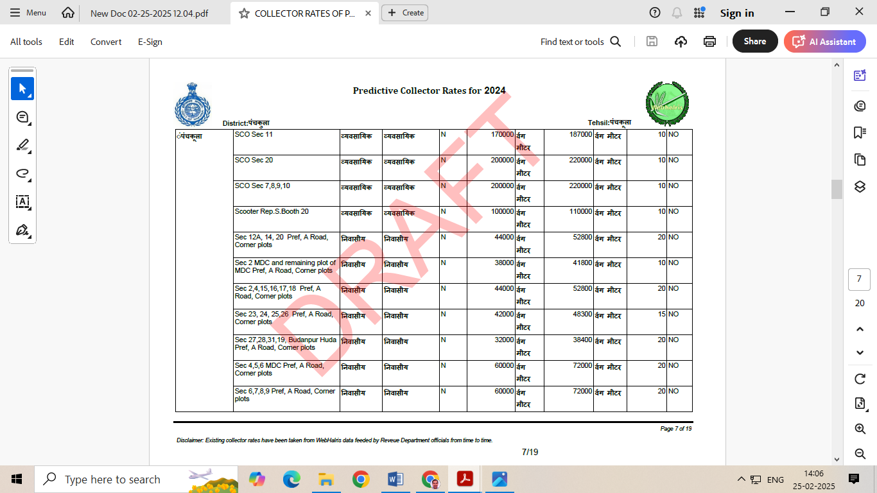

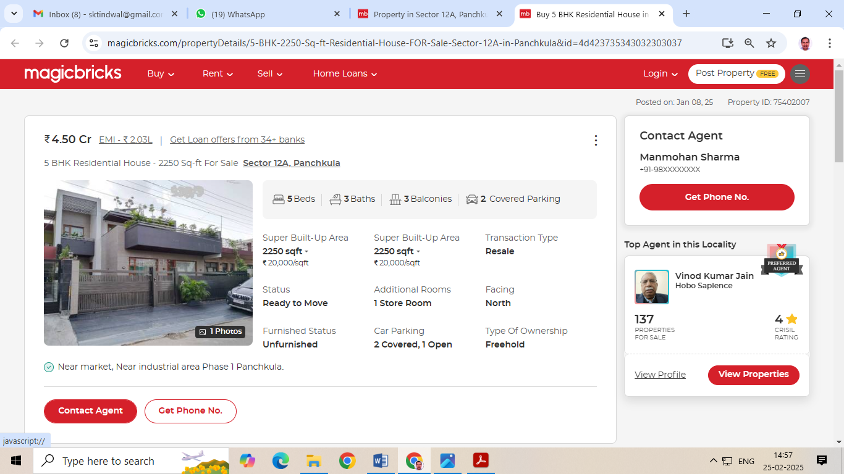

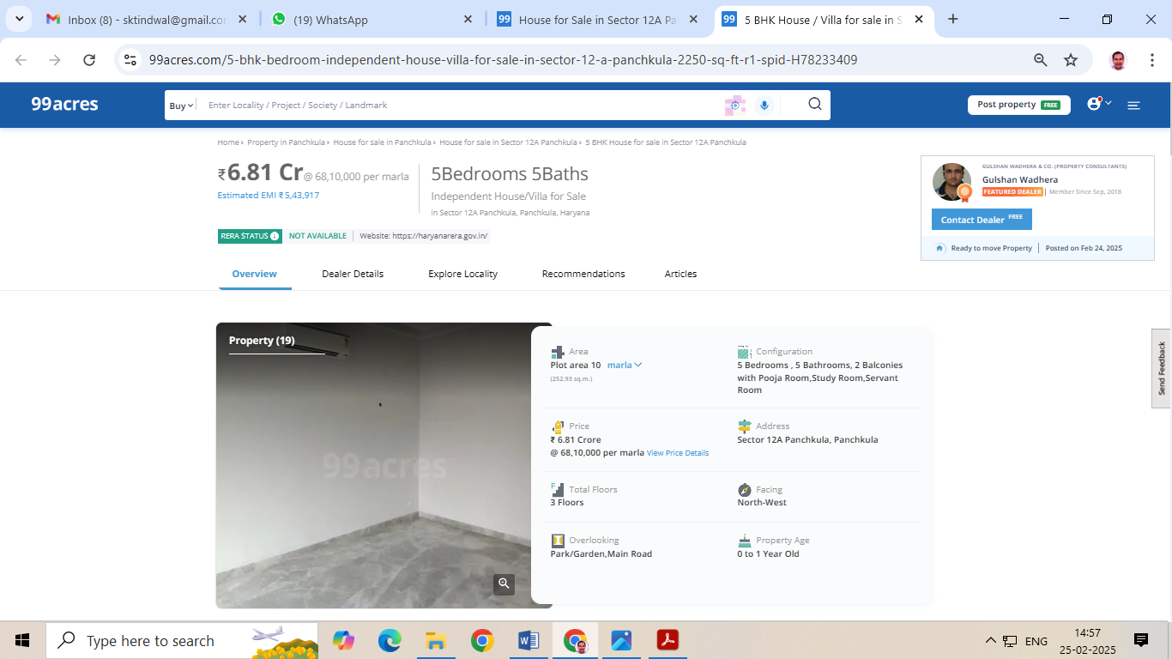

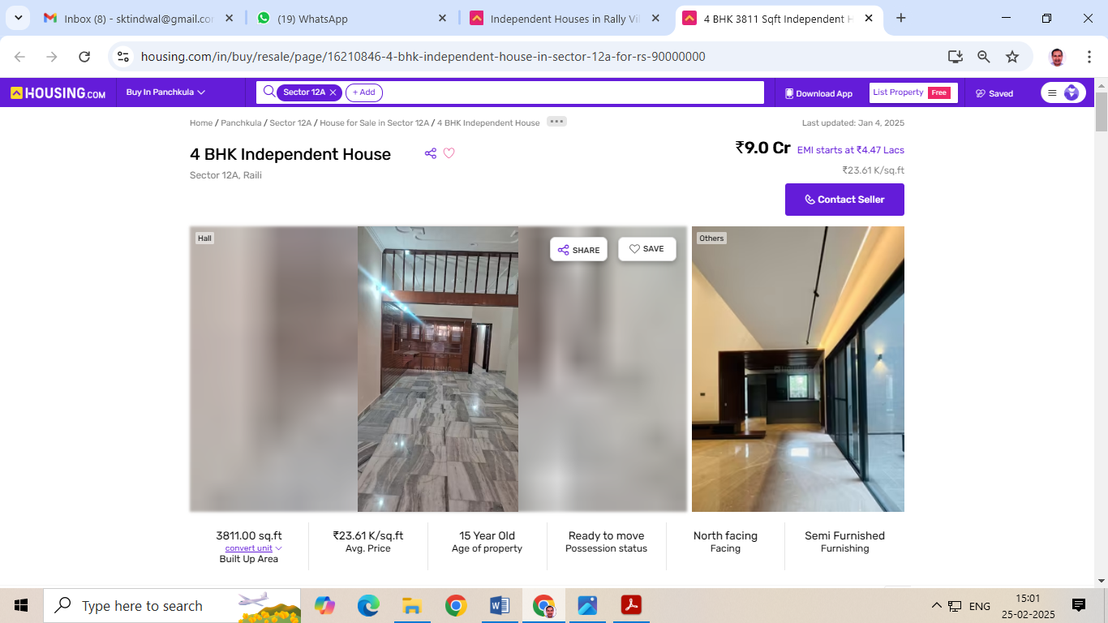

**Photos of H.No. 86, Sector -12A, Urban Estate, Panchkula , Distt. Panchkula**

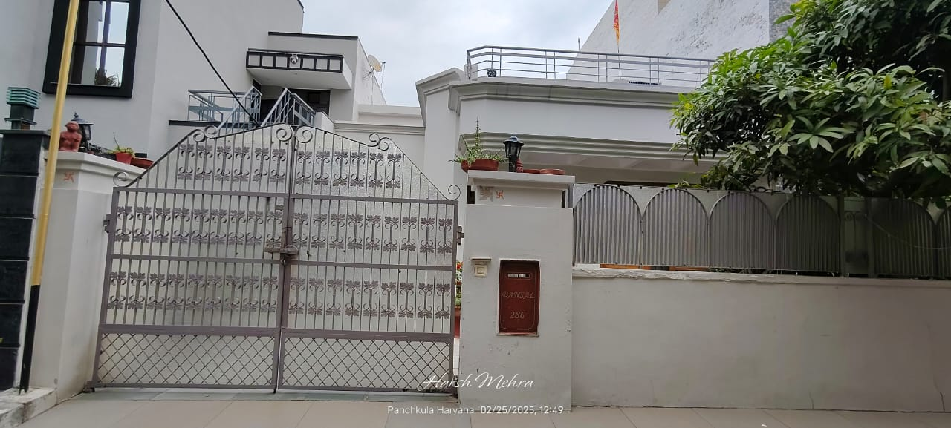

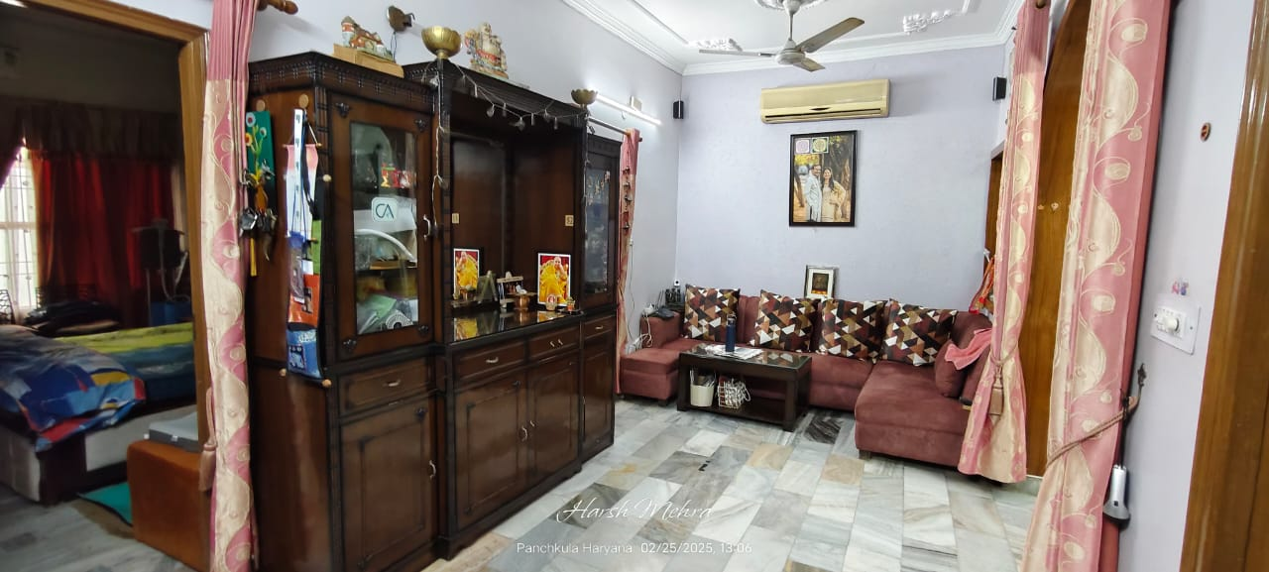 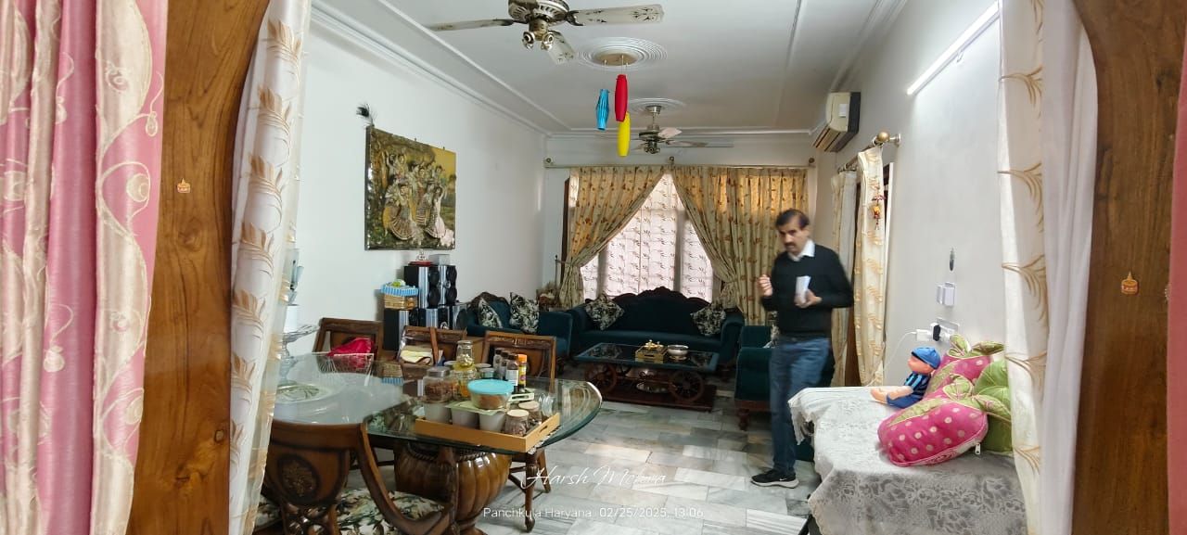

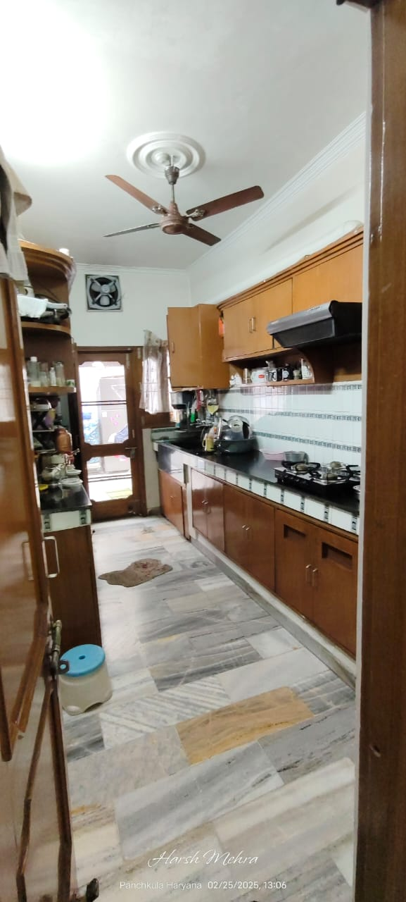 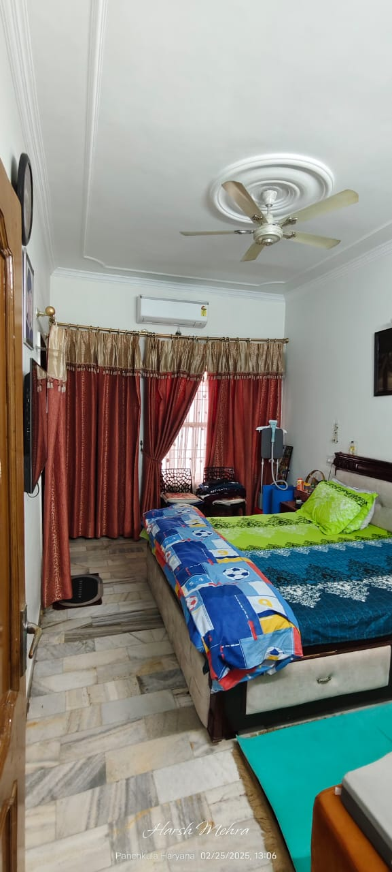 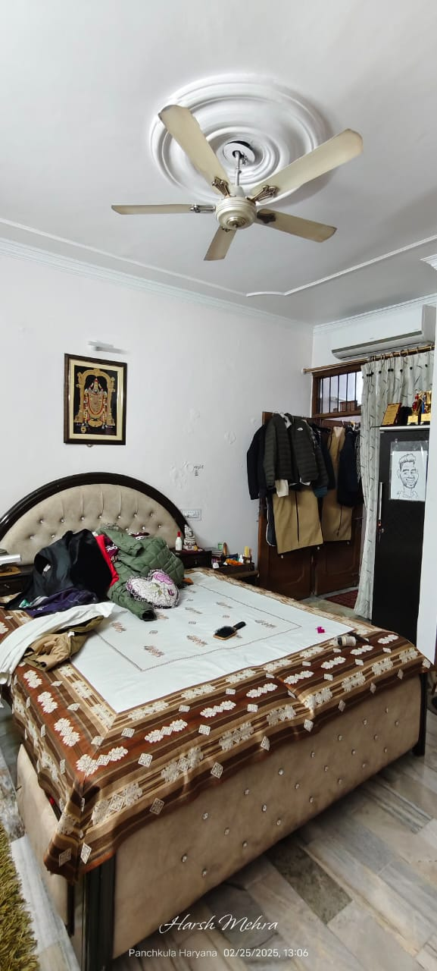 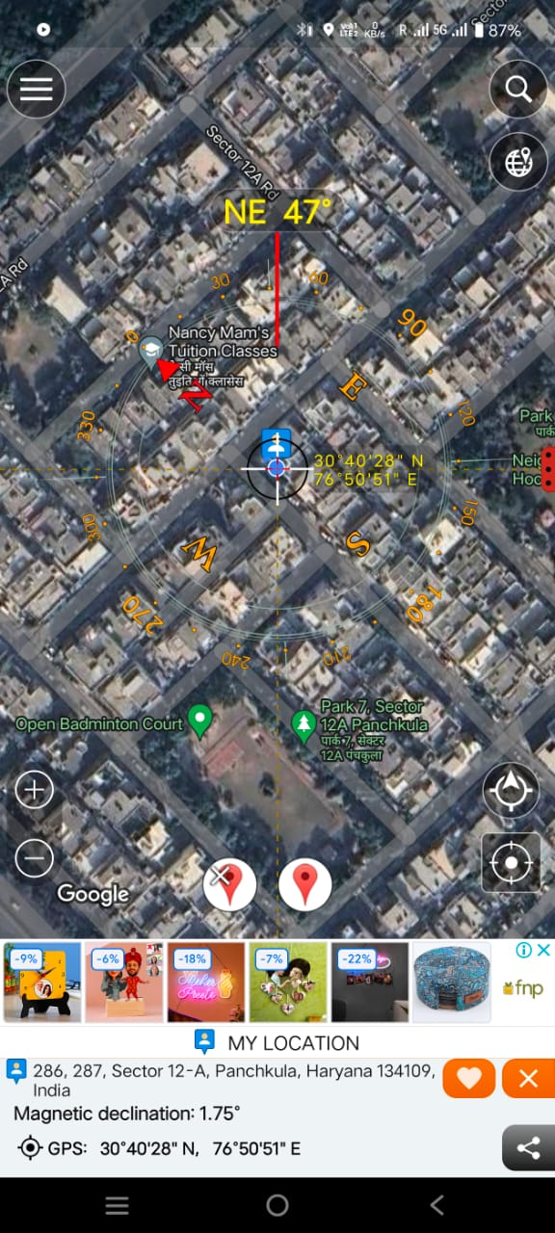

**Google Location**

**Format A (Annexure-22)**

**Format of undertaking to submitted by Individuals/proprietor/partners/direction DECLARATION-CUM-UNDERTAKING**

I,Surinder Kumar Tindwal son of Late Sh. Chhelu Ram do hereby solemnly affirm and state that: a. I am a citizen of India b. I will not undertake valuation of any assets in which I have a direct or indirect interest or become so interested at any time during a period of three years prior to my appointment as valuer or three years after the valuation of assets was conducted by me c. The information furnished in my valuation report dated DD-MM-YYYY is true and correct to the best of my knowledge and belief and I have made an impartial and true valuation of the property. d. I have personally inspected the property on DD-MM-YYYY The work is not subcontracted to any other valuer and carried out by myself. e. Valuation report is submitted in the format as prescribed by the Bank f. I have not been depanelled/ delisted by any other bank and in case any such depanelment by other banks during my empanelment with you, I will inform you within 3 days of such depanelment. f. I have not been removed/dismissed from service/employment earlier g. I have not been convicted of any offence and sentenced to a term of imprisonment h. I have not been found guilty of misconduct in professional capacity L have not been declared to be unsound mind J. I am not an undischarged bankrupt, or has not applied to be adjudicated as a bankrupt; k. I am not an undischarged insolvent L. I have not been levied a penalty under section 2711 of Income-tax Act, 1961 (43 of 1961) and time limit for filing appeal before Commissioner of Income tax (Appeals) or income-tax Appellate Tribunal, as the case may be has expired, or such penalty has been confirmed by Income-tax Appellate Tribunal, and five years have not elapsed after levy of such penalty m. I have not been convicted of an offence connected with any proceeding under the Income Tax Act 1961, Wealth Tax Act 1957 or Gift Tax Act 1958 and n. My PAN Card number/Service Tax number as applicable is o. I undertake to keep you informed of any events or happenings which would make me ineligible for empanelment as a valuer

I have not concealed or suppressed any material information, facts and records and I have made a complete and full disclosure q. Thave read the Handbook on Policy, Standards and procedure for Real Estate Valuation, 2011 of the IBA and this report is in conformity to the "Standards" enshrined for valuation in the Part-B of the above handbook to the best of my ability r. I have read the International Valuation Standards (IVS) and the report submitted to the Bank for the respective asset class is in conformity to the "Standards" as enshrined for valuation in the IVS in "General Standards" and "Asset Standards" as applicable s. I abide by the Model Code of Conduct for empanelment of valuer in the Bank (Annexure V-A signed copy of same to be taken and kept along with this declaration) t. I am registered under Section 34 AB of the Wealth Tax Act, 1957. (Strike off, if not applicable) u. I am valuer registered with Insolvency & Bankruptcy Board of India (IBBI) (Strike off, if not applicable) v. My CIBIL Score and credit worthiness is as per Bank's guidelines, w. I am the proprietor/partner/authorized official of the firm/company, who is competent to sign this valuation report. x. I will undertake the valuation work on receipt of Letter of Engagement generated from the system (i.e. LLMS/LOS) only. y. Further, I hereby provide the following information.

|  |  |  |
| --- | --- | --- |
| **SlNo.** | **Particulars** | **Valuer comment** |
| 1 | background information of the asset being valued; | **H.No. 86, Sector -12A, Urban Estate, Panchkula , Distt. Panchkula** |
| 2 | purpose of valuation and appointing authority | Bank’s purpose |
| 3 | identity of the valuer and any other experts involved in the valuation; | Surinder Kumar Tindwal |
| 4 | disclosure of valuer interest or conflict, if any; | NO |
| 5 | date of appointment, valuation date and date of report: | 24.02.2025, 24.02.2025, 24.02.2025 |
| 6 | inspections and/or investigations undertaken; | Inspection on 24.02.2025 and meeting/ discussion/inquiry with property consultants of the area |
| 7 | nature and sources of the information used or relied upon; | Real estate web portals and property consultants of the area |
| 8 | procedures adopted in carrying out the valuation and valuation standards followed; | Market approach adopted being the property non income fetching and marketable |
| 9 | restrictions on use of the report, if any; | For exclusive use of Canara Bank Branch -Sector 11 , Panchkula and no other else. |
| 10 | major factors that were taken into account during the valuation; | Location, size, direction, frontage along road, specifications used in building and workmanship |
| 11 | major factors that were not taken into account during the valuation; | NA |
| 12 | Caveats, limitations and disclaimers to the extent they explain or elucidate the limitations faced by valuer, which shall not be for the purpose of limiting his responsibility for the valuation report. | **i**. I/We have not verified the title deeds of the properties with the records of registrar’s office as this is beyond the agreed scope of our services stated in our engagement letter.  ii. I/We assume no responsibility for the legal matters including, but not limited to, legal or title concerns. The assets and interests therein have been valued free and clear of any liens or encumbrances unless stated otherwise. No hidden or apparent conditions regarding the subject assets or their ownership are assumed to exist. No opinion of title is rendered by this report and a good title is assumed.  iii. The RV has endeavored to visually identify the land boundaries and dimensions; however, he is not a surveyor. So where there is a doubt about the precise position of the structures, it is recommended that a Licensed Surveyor be contacted.  iv. The physical condition of the improvements was based on visual inspection. No liability is assumed for the soundness of the structure since no engineering tests were made at the site. Any unknown conditions existing at the time of inspection could alter the value. No responsibility is assumed for latent defects of any nature whatsoever, which may affect value, nor for any expertise required to disclose such conditions.  v. Where a sketched plan is attached to this report, it does not purport to represent accurate architectural plans. Sketch plans and photographs are provided as general illustrations only.  vi. Unless otherwise stated as part of the terms of engagement, the RV has not made a specific compliance survey or analysis of the various permits and licenses under central, state and local laws / regulations applicable to the operation and use of the subject property, and this valuation does not consider the effect, if any, of non-compliance.  vii. The sale of the subject property is assumed to be on an all cash basis. Financial arrangements would affect the price at which the property may sell for if placed on the market.  viii. Value varies with the purpose and date. This report is not to be referred if the purpose is different other than mentioned.  ix. The actual realizable value that is likely to be fetched upon sale of the property under consideration shall entirely depend on the demand and supply of the same in the market at the time of sale.  x. In the course of the valuation, we were provided with both written and verbal information. We have however, evaluated the information provided to us by the Company through broad inquiry, analysis and review but have not carried out a due diligence or audit of the information provided for the purpose of this engagement. Our conclusions are based on the assumptions, forecasts and other information given by/on behalf of the Company.  xi. We are independent of the client/company and have no current or expected interest in the Company or its assets. The fee paid for our services in no way influenced the results of our analysis.  xii. Our report is meant for the purpose mentioned above and should not be used for any purpose other than the purpose mentioned therein. The Report should not be copied or  reproduced without obtaining our prior written approval for any purpose other than the purpose for which it is prepared. |

**Date: 24.02.2025**

**Place: Panchkula**

**Signature**

**(Name of the approved valuer and seal of the Firm/company)**

**Format-B (Annexure-23)**

**MODEL CODE OF CONDUCT FOR VALUERS**

All the empanelled Valuers are required to adhere to the code of conduct given as under:

Integrity and Fairness:

1. A Valuer shall, in the conduct of his/its business, follow high standards of integrity and faimess in all its dealings with his/its clients and other Valuers

2. A Valuer shall maintain integrity by being honest, straightforward, and forthright in all professional relationships.

3. A Valuer shall endeavour to ensure that he/it provides true and adequate information and shall not misrepresent any facts or situations.

4. A Valuer shall refrain from being involved in any action that would bring disrepute to the profession . A Valuer shall keep public interest foremost while delivering his services

5. A Valuer shall keep public interest foremost while delivering his services.

Professional Competence and Due Care:

6. A Valuer shall render at all times high standards of service, exercise due diligence, ensure proper care and exercise independent professional judgments

7. A Valuer shall carry out professional service in accordance with the relevant technical and professional standards that may be specified from time to time.

8. A Valuer shall continuously maintain professional knowledge and skills to provide competent professional service based on up to date developments in practice, prevailing regulations/guidelines and techniques.

9. In the preparation of a Valuation report, the Valuer shall not disclaim liability for his/its expertise or deny his/its/duty of care, except to the extent that the assumptions are based on statements of fact provided by the company or its auditors or consultants or information available in public domain and not generated by the Valuer

10. A Valuer shall not carry out any instructions of the client insofar as they are incompatible with the requirements of integrity, objectivity and independence.

11. A Valuer shall clearly state to his client the services that he would be competent to provide and the services for which he would be relying on other Valuers or professionals or for which the client can have a separate arrangement with other Valuers. Independence and Disclosure of Interest:

12. A Valuer shall act with objectivity in his fits professional dealings by ensuring that his/its decisions are made without the presence ofany bias, conflict of interest, coercion, or undue influence of any party, whether directly connected to the Valuation assignment or not.

13. A Valuer shall wherever necessary disclose to the clients, possible sources of conflicts of duties and interest providing un biased services

14. A Valuer shall maintains complete independence in his/its professional relationships and shall conduct the Valuation independent of external influences

15. A Valuer shall not deal in securities of any subject company after any time when he/it first becomes aware of the possibility of his/its association with the Valuation, and in accordance with Bank of India the Securities and Exchange Board of India (Prohibition of Insider Trading) Regulations, 2015 or till the time the Valuation report becomes public, whichever is earlier.

16. A Valuer shall not indulge in mandate snatching or offering 'convenience Valuations' in order to cater to a company or client's needs

17. As an independent Valuer, the Valuer shall not charge success fee (success may be defined as a compensation/ incentive paid to any third party for successful closure of transaction. In this case, approval of credit proposals).

18. In any faimess opinion or independent expert opinion submitted by a Valuer, if there has been a prior engagement in an unconnected transaction, the Valuer shall declare the association with the company during the last five years.

Confidentiality:

19. A Valuer shall not use or divulge to other clients or any other party any confidential information about the subject company, which has come to his/its knowledge without proper and specific authority or unless there is a legal or professional right or duty to disclose.

Information Management:

20. A Valuer shall ensure that he/it maintains written contemporaneous records for any decision taken, the reasons for taking the

decision, and the information and evidence in support of such decision. This shall be maintained so as to sufficiently enable a

reasonable person to take a view on the appropriateness of his/its decisions and actions.

22. A Valuer shall appear, co-operate and be available for inspections and investigations carried out by the authority, any person authorized by the authority, the registered Valuers organization with which he/it is registered or any other statutory regulatory body.

23. A Valuer shall provide all information and records as may be required by the authority, the Tribunal, Appellate Tribunal, the

registered Valuers organization with which he/it is registered, or any other statutory regulatory body.

24. A Valuer while respecting the confidentiality of information acquired during the course of performing professional services shall maintain proper working papers for a period of three years or such longer period as required in its contract for a specific Valuation, for production before a regulatory authority or for a peer review. In the event of a pending case before the Tribunal or Appellate Tribunal,the record shall be maintained till the disposal of the case.

Gifts and Hospitality:

25. A Valuer or his fits relative shall not accept gifts or hospitality which undermines or affects his independence as a Valuer

Explanation-For the purposes of this code the term 'relative' shall have the same meaning as defined in clause (77) of section 2 of the companies Act, 2013 (18 of 2013).

26. A Valuer shall not offer gifts or hospitality or a financial or any other advantage to a public servant or any other person with a view to obtain or retain work for himself/itself, or to obtain or retain an advantage in the conduct of profession for himself/itself.

Remuneration and Costs:

27. A Valuer shall provide services for remuneration which is charged in a transparent manner, is a reasonable reflection of the work necessarily and properly undertaken, and is not inconsistent with the applicable rules. Bank of India.

28. A Valuer shall not accept any fees or charges other than those which are disclosed in a written contract with the person to whom he would be rendering service.

Occupation, employability and restrictions

29. A Valuer shall refrain from accepting too many assignments, if he/it is unlikely to be able to devote adequate time to each of his/its assignments.

30. A Valuer shall not conduct business which in the opinion of the authority or the registered Valuer organization discredits the profession.

**Signature**

**(Name of the approved valuer and seal of the Firm/company)**

**Part-G CERTIFICATE**

1. It is hereby certified that in my opinion

The **present market value** of the property discussed in the report above by adoping pravailing market rate for land is **Rs. 476.70 Lac (Rs Four Crore seventy six Lac seventy thousand Only).**

* 1. The forced sale/ distress value of the property is estimated **as 25 % less** than the present market value.

1. Number of title deed(s) involved in this house is one The relevant document for the subject flat in the opinion of this valuer is the **Sale deed** With **registration number** **4087 dated 28.03.2013** registered in the Registrar’s Office,Panchkula,Hr.
2. If this Property is offered as Collateral security, the concerned financial institution is requested to verify the extent of land shown in this valuation report with respect to the latest legal opinion
3. Value varies with the purpose and date of valuation .This report is not to be referred if the purpose is different other than mentioned in 1(I)
4. The property was inspected on 24.02.2025 by Er. Surinder Kumar Tindwal Panel Valuer in the presence of Borrower Sh. Hardik Nain
5. The legal aspects were not considered in this valuation
6. This valuation work is undertaken by the valuer based upon the request from the Chief Manager ,Canara Bank, SME , branch -sector 11, Panchkula .
7. Any other details

**Signature of Panel Valuer**

Place:Panchkula

Date : 24.02.2025

Note : This report contains 12 pages

Enclosures :

1. Key plan showing the location of the property
2. Sketch showing the location of the subject flat with reference to the floors.
3. Sketch of the flat if available
4. Photograph of owner/ representative with property in background
5. Screen shot of longitude/latitude and co-ordination of perperty using GPS/Various apps/ Internet sites.